CPSC131 – (20 pts) Linear Regression

Submit one EXCEL file in the drop box

Part 1, Matlab:
1-
a) Import the commerce.txt file (space should automatically be selected, click ‘next’, then ‘finish’).
b) Open ‘data’ in the Variable Editor (have data selected in the Workspace window and then click the 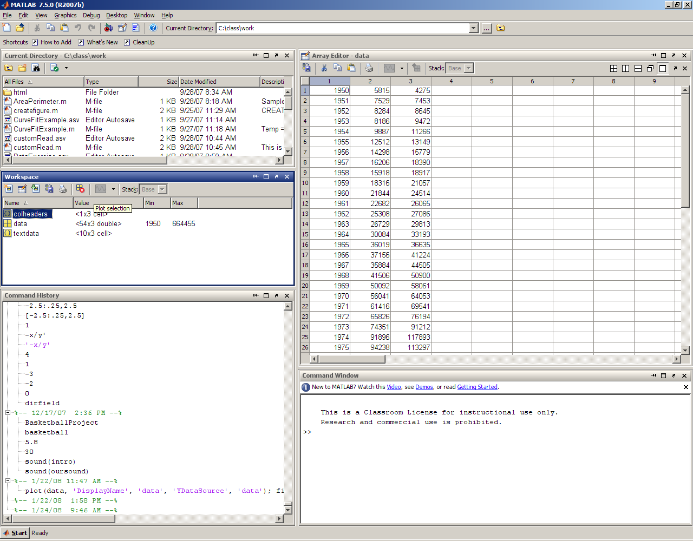 button.

c) Create a 54 x 1 array ‘Year’ from the first column (right click on the first column and select ‘Create variable From Selection’, then rename it ‘Year’).

4) Create a 54 x 2 array from the 2nd and 3rd columns (hold Shift or Ctrl key to select both columns) and name it ‘Commerce’.

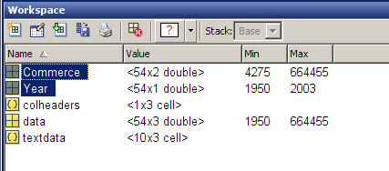
e) In the Workspace widow, select ‘Year’, then ‘Commerce’ (the order is important). Use the Plot Selection menu (more plots) to plot Commerce vs Year as a bar plot.
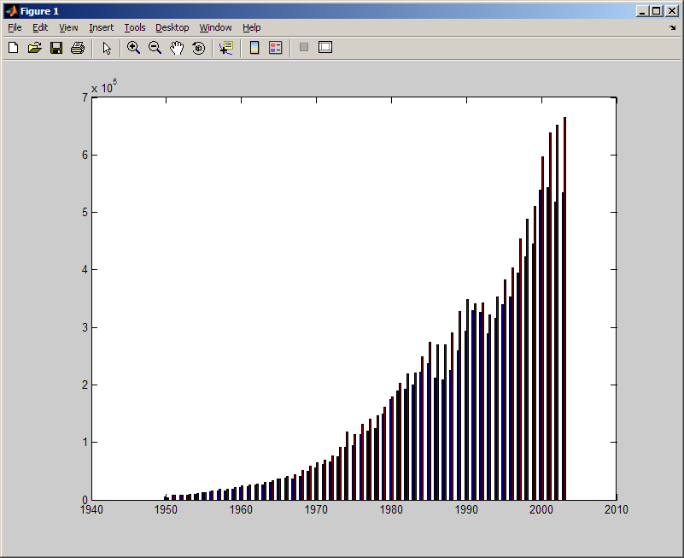

f) Add a legend to the figure by clicking the ‘legend’ button. 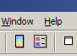 Open the Property Editor (under ‘View’). Select the legend and then click on ‘More Properties’. From the list double lick on the grid next to the ‘String’ property. Change the legend so the first column is ‘Imports’ and the second column is ‘Exports’. Move the legend to the upper left hand corner.

g) Click on the x-axis and change the limits to min of 1950 and max of 2000.

h) Enhance the plot by adding the title ‘German Foreign Commerce, 1950 – 2000’, axis labels, change fonts and colors.

i) Copy your finished figure to WORD and submit it in the appropriate dropbox. Be sure your name and the name of the assignment are in the header.

Commerce.txt file from The MathWorks, Inc.

2- The subject of thermodynamics makes extensive use of tables. Although many properties can be described by fairly simple equations, others are poorly understood, or the equations describing their behavior are very complicated. It is much easier just to tabulate the data. The following table gives data for steam at 0.1 MPa (approximately 1 atm). (Problem from ‘Engineering Computation with MATLAB’ by D Smith)

a) Enter the data into an EXCEL file and name it thermo.
Temperature, °C | Internal Energy, kJ/kg
100 | 2506.7
150 | 2582.8
200 | 2658.1
250 | 2733.7
300 | 2810.4
400 | 2967.9
500 | 3131.6

b) Import the file into MATLAB. Create a variable for each column. Name them Temperature and InternalEnergy. In the Workspace window, select ‘Temperature’ and then ‘InternalEnergy’ and create a scatter plot. Under Tools open Basic Fitting and add a linear equation to the plot. Include a plot of the bar residuals. Under View open the Property Editor and add titles and axes labels to each plot.

Part 2 Excel:

Use EXCEL to find the coefficients of linear regression equation and the coefficient of determination for the following two problems. Then use Trendline tool to find the regression coefficient and compare your results for both methods. Properly label your plots.

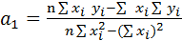 , r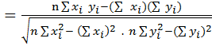

3-
Use the least – square regression to fit a straight line to the data given below. Create a table in EXCEL and compute the slope, y intercept, and the coefficient of determination. Show all work to receive full credit. Express your answers to four decimal places.
x | 0 | 2 | 4 | 6 | 9 | 11 | 12 | 15 | 17 | 19
y | 4 | 5 | 6 | 5 | 8 | 7 | 6 | 9 | 11 | 12

4-
It is known that the tensile strength of a plastic increases as a function of the time it is heat treated. The following data is collected:
Time (min) | 10 | 15 | 20 | 25 | 40 | 50 | 55 | 60 | 75
Tensile Strength | 5 | 20 | 18 | 40 | 33 | 54 | 70 | 60 | 78

Fit a straight line to this data and use the equation to determine the tensile strength at a time of 32 minutes.

